Great Things About Printing Services

Creative visuals draw attention in busy commercial spaces. Bright displays invite people to pause and observe. Many businesses rely on printing companies for this purpose. A skilled printing company understands visual appeal and clear messaging. Professional printers produce bold graphics with balanced colours. Modern printing services help brands communicate quickly and clearly. Attractive signs guide visitors toward products or services. Large displays create instant visual interest. This approach supports both awareness and engagement. Sign makers often design signs that feel welcoming. These creative displays build curiosity and interest. Eye catching graphics help messages stand out. Simple ideas expressed through quality printing capture attention easily. Colourful banners and bold posters influence how people notice spaces. Banner printing creates striking displays for shops and promotions. Large format printing also produces wide visuals for windows and walls. Large format digital printing delivers bright and smooth graphics. Visit the following site, if you are looking for additional information concerning printing services buckinghamshire.

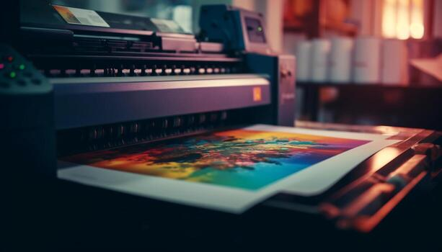

These visuals help businesses appear lively and engaging. Printing services help maintain clear brand presentation. Skilled printers prepare balanced layouts and neat prints. Many printing companies suggest banners for seasonal promotions. These displays often attract passing visitors instantly. Sign makers also support creative signage & printing solutions. Clear banners and posters communicate messages quickly. Attractive visuals encourage people to explore products and services further. Printed leaflets remain powerful tools for sharing messages. Leaflet printing spreads information in a friendly and simple way. Clear designs capture interest quickly and naturally. Many businesses combine leaflet design and printing for better results. Well planned layouts guide readers through helpful details. Skilled printers produce sharp and tidy prints. Printing companies often recommend leaflets for promotions and announcements. A reliable printing company ensures neat colours and balanced style. Printing services also assist with layout ideas and formats. Creative leaflets feel inviting and informative. These small printed pieces encourage curiosity and engagement. Professional signage creates a strong visual identity for any business. Sign makers understand how colour and shape influence attention.

Bold lettering and graphics create memorable impressions. Many printing companies offer complete signage & printing solutions. This service combines creative ideas with quality printing. Large format printing works well for storefront displays. Large format digital printing also produces vibrant outdoor graphics. Skilled printers help maintain consistency in colours and layout. A trusted printing company supports clear brand communication. Printing services help create displays that appear welcoming and attractive. Good signage encourages people to explore nearby products or services. Creative printing supports lasting impressions and brand visibility. Banner printing highlights promotions with colourful and engaging visuals. Leaflet printing shares messages in a simple and friendly format. Many businesses rely on leaflet design and printing for campaigns. Skilled printers ensure clean and balanced results. Printing companies often suggest combining several printed materials. A reliable printing company helps maintain clear brand presentation. Large format printing creates bold displays for windows and walls. Large format digital printing delivers vibrant and modern graphics. Sign makers complete the process with thoughtful signage & printing solutions. Together these printing services attract attention and inspire curiosity.

